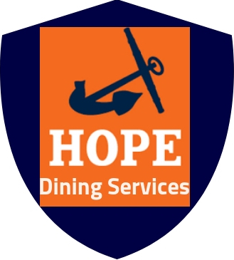
Hope College Dining Services
Holland, MI 49423
News Release Tabitha Burrink
November 12, 2018 (219) 742-1595
tabitha.burrink@hope.edu

Hope College Pilots Dining Hall App
Holland, Mich.─ Hope Yum is a mobile dining hall mobile application, that lists the ingredients of entrees and has a meal feedback section. Hope Yum will be available for all Hope College students Spring 2020.

“The development of Hope Yum has been in the works for quite some time now,” says Lindsey Fick, the Corporate Dietitian of Creative Dining Services, “We wanted it to benefit all people of Hope College, Hope Yum is a way to help people with dietary needs.”

When you open Hope Yum you are able to enter your dietary needs as a filter. The app calculates what you can eat that day. Hope Yum communicates where the food is located in the dining halls. This decreases the time it takes students to find meals that meet their dietary needs or restrictions.
-MORE-
Hope College Pilots Dining Hall App…. Page 2 of 2

“There are super long lines, and I only have a limited amount of time to eat, so I go to the line that is most accessible,” expressed a Hope College Student, “Most of the time that option is not healthy or is healthy, and just tastes terrible.”

For more information regarding the dining hall app please go to: hope.edu/offices/dining-services/

“It is our job to create 21 adequate meals per week,” says Head Chef Tom Hoover, “The dining halls aim to go above and beyond. We want students and faculty to have access to food that meets their individual needs.”
###

