Exclusive: Can Anyone Escape The Freshman 15? FEATURE STORY
BY: TABITHA BURRINK
November 12, 2018
I remember my freshman year of college learning all about the infamous Freshman 15. People talked about the Freshman 15 like it was a horror story. The way people described how it would take hold of you without your realization terrified me. Everyone tells you that you will get the Freshman 15 no matter how hard you tried escape it, but they never explained why?
College is like a relationship. Not just any relationship, like a full on boyfriend and girlfriend, going strong for 4 years, kind of relationship. When you have failures in college it is like a bad fight with your boyfriend. If you’re like me, you go to the dining halls and drown your sorrows in food. Then go to your dorm cry and binge watch one of your favorite Netflix episodes until you fall asleep. The thing is you might have only a couple of fights with your boyfriend, but in college you have many different types of failures such as: a rejection letter from an internship you really wanted, when the registration process doesn’t go your way and you don’t get your first choice of classes, a bad grade on tests and quizzes even though you studied for hours, just the normal stress of college, or roommate issues. The purpose of this is not to frighten you in any way, but if you can make it through college you can make it through any life situation. College is hard work there is no doubt about that, but it is how manage those hardships that will make you successful in the long run.
As you navigate your way through continue to think of college as a relationship, and you will be successful. Always try to find a way to steady that relationship, try to make it as harmless as possible. I went through some hard times my freshman year, and instead of Daddy Issues in a relationship I had a love/hate relationship with Jimmy Johns. I call these my Jimmy Johns Issues. Many people I knew, including myself, would prioritize school over eating. We found ourselves having Jimmy Johns delivered a couple times a week, and this caused us to waste our meal swipes. Do not do what we did. These were the lessons we learned from the first semester of college, and we changed them all around the next couple of years. We developed ways for you to live your best healthy life while attending college.
The Freshman 15 can be managed. Here is the first tip, drink loads of water. Before every meal drink a glass of water, because then you will not overeat. This may sound stupid, but it will benefit you while you’re in the dining halls. This is a psychological way to induce self control. The consumption of water is also great for your body. It makes your skin silky smooth, benefits your digestive system, allows for nutrients to be transported throughout your body, and helps regulate body temperature. All of these things are affected by simply drinking water, so why not have a glass of water before you head to a meal?
Try to always grab a piece of fruit on your way out of the dining halls. It is very common to grab an ice cream cone when you leave the dining halls. You do not have to completely get rid of ice cream just don’t make it a habit. Tell yourself Monday through Thursday I will take an apple or banana after every meal, and on Friday I will have an ice cream cone. Availability of fruit in your dorm rooms can help solve monetary issues and night hunger. Therefore, your money will not disappear from food expenses at the grocery store. If you don’t like fruit then while you’re in the dining halls make it mandatory to eat at least one vegetable with each meal you have. These goals can help you stay on a healthy track and healthy way of life. When people eat healthy they usually hold themselves hostage, do not torture yourselves! It is okay to reward yourself. For example, you finish all of your midterm, and your friends are going out to Peachwave to celebrate with some frozen yogurt, go with them! Just because people are scared of the Freshman 15 does not mean the social aspects of your life should suffer. Food is okay as long as long as you eat it in moderation.
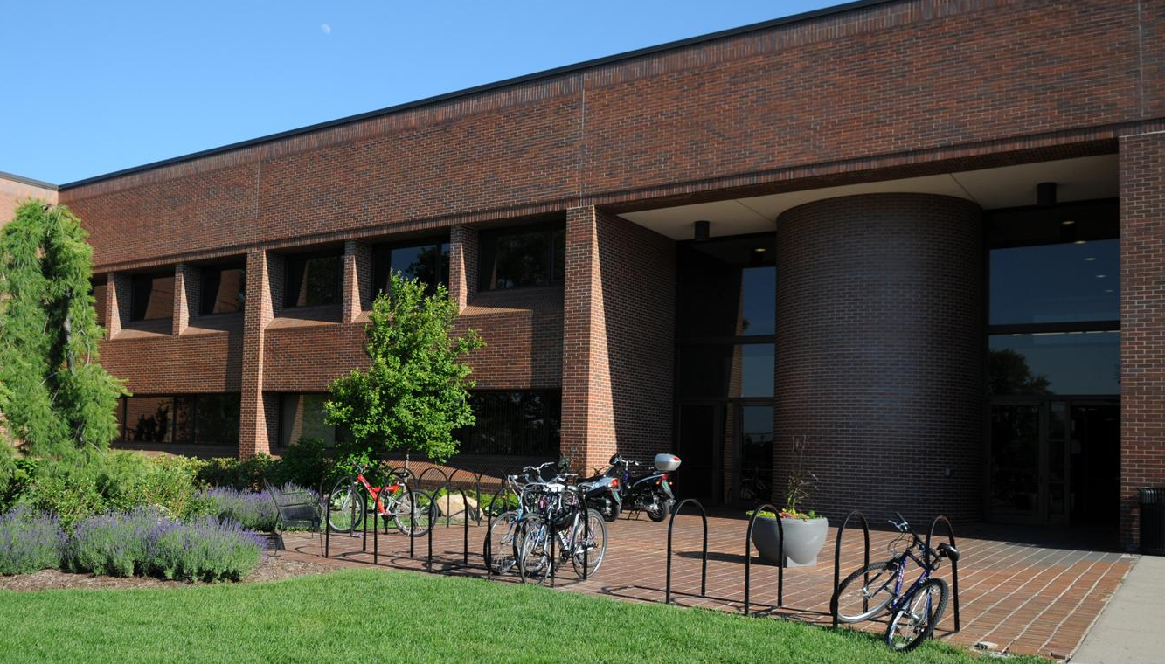
Try going to the gym. The gym isn’t always fun to attend, but it helps relieve stress and if you did consume more unhealthy foods than normal you can burn those calories off. Even if you just walk for 30 minutes it helps. If swamped with homework bring it to the gym, and read it while you walk on a treadmill or just ride the bike machine. Then while you’re at the gym you will not be stressed about outside matters. We have two great gym facilities on Hope College’s campus, Devos and the Dow. They are free to all students. No matter what level of fitness you’re at stop on in. If you do not know where to begin ask one of the staff, and they can tell you some workouts to do.
This next generation can escape the infamous Freshman 15. Generation X has already shown they are a more health conscious generation. If you want to try out these tools connect with your peers, because the power is always within numbers. It could forever change how people talk about college. Hopefully the fear of weight gain while in college will start to disappear. Just use these tricks and you will be good as gold. Have your relationship with college be happy and healthy, and not a hot mess.
For More Information Visit:
https://hope.edu/offices/dining-services/
###

