Girl Pullers: Why Are People So Against Them? FEATURE STORY
BY: TABITHA BURRINK
September 24, 2018

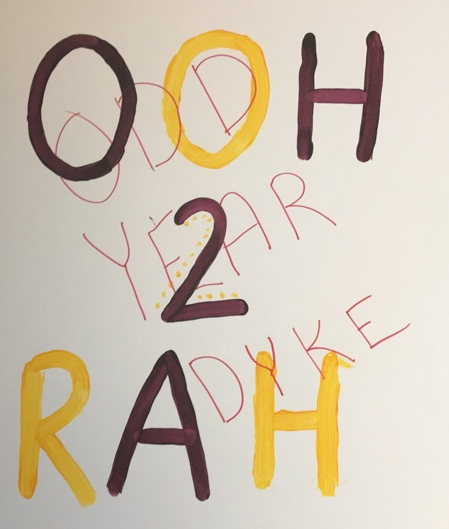
One of the strongest people I have ever laid eyes on is my puller. My puller is not a bodybuilder or some athletic individual. My puller is a petite, 135 pound woman. She lives and breathes Pull. Pull is a three hour tug-of-war where freshman compete against sophomores. I do not understand why people are so against her being a puller. She was apart of the 120th year of Pull and helped us swim as freshman. My puller is a tough individual that trained all year just for this three week tradition. It is not an easy task that we put our bodies through, but she prevails through each three hour practice and every eight hour Saturday practice. She fights to achieve absolute perfection.
My puller’s name is Claire Butcher. Butcher is the person people go to when they need to be hyped up. She is generous, and would give the shirt off her back if it means she is making someone’s day better. She is a lovely human that is also capable of flipping a switch inside her that allows her to get down to business. She becomes a machine that wants to be programmed. Give her a task and she will execute every inch of it.
Last week, Butcher’s door was vandalized. On the poster that the moralers had made for her, someone had written across in red capital letters, “ODD YEAR DYKE”. I was in awe that someone went out of their way to find where she lived and make it known that they were there. There is still a search to find out who committed this childish crime. Whoever it was should be ashamed of themselves, and know that they didn’t get a rise out of anyone. Claire has a band of people who are there for her no matter what, and she knows that she is loved unconditionally. I am so thankful that Butcher has a good head on her shoulders and is a proud, strong independent woman.
I would like for the person who committed this crime to ask themselves these questions, “What if Claire Butcher was an unstable self conscious individual?, What if she was bullied so much in high school about this topic?, What if she had thoughts about ending her life?” This could have easily driven her over the edge, and we could all be at a funeral right now instead of the 121st year of Pull. Just because Claire Butcher is naturally pretty and does not wear makeup that somehow makes her a dyke? When I saw what the individual did to her poster I immediately forgot that it was 2018. I felt as if I was in the 1930s and discrimination was still present in society. Why are people still using the word “dyke” as an insult? This is the land of the free for a reason. People are allowed to dress however they choose, get involved in whatever they want, and marry whomever their hearts desire. It is people like this that keep us in the past and do not allow us to progress as a generation. We evolved as a nation for a reason, and these haters need to decide if they are going to join us in the 21st century or wither in the past. Claire Butcher rightfully earned her position on the 21 Pull Team. She does all the same workouts as the men, and never complains that she cannot do something. She is a fighter and is very respected amongst the Pull Alumni.
Bullying is not something that I take lightly, because I was bullied so badly throughout middle school. In 7th grade I was on Facebook going through pictures with my “best friend” at the time. I went to the bathroom, and my “best friend” went on all of my other friend’s Facebook pages and commented nasty things on their pictures. Before I came back she switched back to the page we were just at, and I didn’t find out what she had done till I went to school on Monday. I will never forget that week, it was the worst week of my life. My “best friend” continued to stay by my side, because I thought my account just had been hacked. Behind my back my “best friend” spread to everyone that she was a witness to Facebook incident. When I found out what she had done I tried to falsify those claims, but no one believed me. That’s when I began eating lunches by myself, and the bullying began to escalate. Random notes began to show up in my lockers from people, on every note it said I should kill myself, and/or just do everyone a favor and disappear. I was unable to go to the lunch room without getting milk or food spilt on me, or verbally abused. These were just some of the minor assaults that I endured for an entire year. I was too scared to tell anyone. When I came home from school, months later, with bruises all over me I was unable to hide them from my mom, so I had to come clean about everything. She brought it to the school and my “best friend” finally came clean and admitted she started the whole thing. It was too late though the damage was done, and everyone’s minds were made up that I was the villain. My mom took me out of the school district and enrolled me in private school. I had to get a lot of counselling, but after a year away I was able to heal. I ended up making the decision to enroll back into my old school district for high school. I honestly wanted to go back to my old school district. I wanted those people that bullied me to see that they could not knock me down. I got back up stronger than ever, and I ended up receiving a division one scholarship to play soccer at Indiana State University. Those who bullied me never messed with me again, because they saw how much I channeled their negativity into greatness.
One thing that I want everyone to grasp is that asking for help does not show weakness it shows strength and power. Claire could of kept the defilement of her door hidden, but she wanted to spread that this event made her even stronger than she already is. She used her voice to inform people that bullying is a real thing, and we must acknowledge it for it to begin to fade away. I always tell myself that the hardships I endured make me the person I am today. Everyone has a purpose in life and hard times ALWAYS PASS. If Claire and I are able to keep our heads held high, then everyone else should do the same. Claire and I work hard everyday trying push ourselves, break walls, and show those around us that we will never quit. That is why she is my puller and I am her moraler. We just had an immediate understanding that we were fighters, and we share the same end goal. It is normal to get knocked down, but it’s how you get back up that really matters.

