Research Report
By: Tabitha Burrink
Hope College Campus Safety
Goal: Research how students perceive Hope College’s Campus Safety Program.
Strategy: Conduct a survey to a minimum of 250 students across Hope College’s campus to obtain data on their knowledge of Campus Safety.
Survey Questions:
- Do you know a Campus Safety officer?
- Would you like to know a Campus Safety officer?
- Are you aware of all the services Campus Safety provides?
- Which of these changes is most important to you?
Demographics:
Gender: Female: 83%; Male: 16%; Other: 1%
Race: White 72%; Hispanic/Latinx: 21%; Black: 3%; Biracial: 3%; African: .5%; Other: .2%
Class Standing: Freshman: 33%; Sophomore: 34%; Junior: 23%; Senior: 9%
Living Situation: Dorm: 74%; Cottage: 20%; Off-Campus: 6%
The demographics of the survey reflects the overall demographics of Hope College’s campus. The majority of the campus is caucasian and female and our results are made up of freshman, sophomore and juniors living at a Hope College dorm which is the main target of our action plan.
Findings:

Do you know a Campus Safety officer?
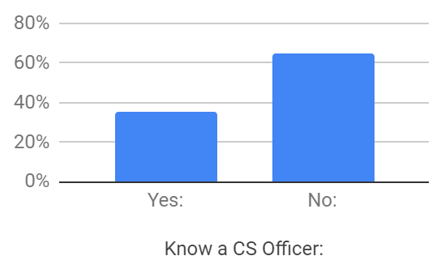

Would you like to know a Campus Safety officer?
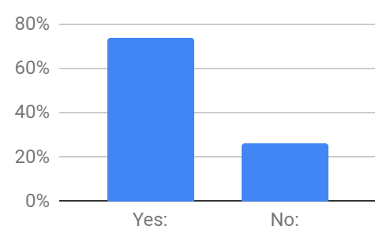
Are you aware of all the services Campus Safety provides?
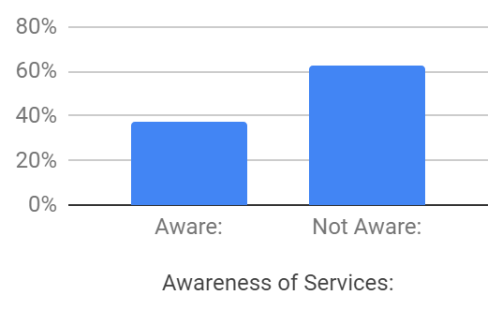
Which of these changes is most important to you?
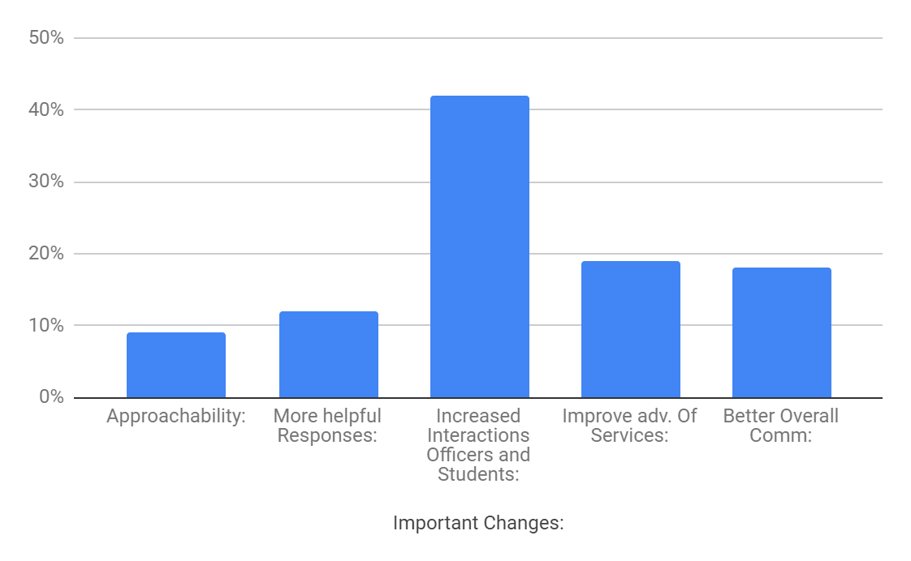
Approachability: 9%

More Helpful Responses: 12%

Increased Interactions between Officers and Students: 42%

Improve Advertisement of Services: 19%

Better Overall Communication: 18%

Comparison: What the students want vs what the students know?
- Our action plan is rooted in connecting Campus Safety with Hope College students. These graphs show that students have not been in contact with Campus Safety officers. Over 63% of students are unsure or do not know their campus safety officer within their building and only 65% of students in general know a Campus Safety officer. Students would like to have the opportunity to get to know Campus Safety officers one on one. Lastly, the finding within, “Which of these changes is most important to you?” 42% of students want and increase in interaction with Campus Safety Officers. In order for Campus Safety to best serve the students there needs to be an increase in interactions between officers and students.
- They also reveal that students are unaware of the services Campus Safety offers. According to the graphs 63% of students are unaware of the services that Campus Safety offer. In order for students to be aware of the services Campus Safety offer there must be a set in stone list of all the services, and have them accessible to all students.

