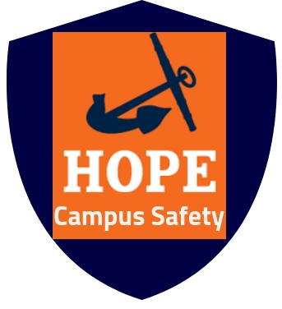
Hope College Campus Safety
Holland, MI 49423
Press Release Tabitha Burrink
November 12, 2018 (219) 742-1595
tabitha.burrink@hope.edu

Hope College’s First Barbecue Jubilee
Holland, Mich.─ Barbecue Jubilee is a Campus Safety event that will take place Sunday, September 1, 2019, 12:00 - 3:00 P.M. in the Pine Grove. This is a time for students and faculty to come and get to know the Campus Safety officers and staff. Come enjoy FREE barbecued food, FREE beverages, and FREE Hope College prizes.

“I have always been fond of growing fruits and vegetables in my garden, grilling them, and sharing my home cooked foods with the students in Kollen Hall,” says Jason Geurink, Security Officer, “The Barbecue Jubilee is a great way for me to get to know more students and faculty, and I cannot wait to grill up some burgers and hot dogs and have a good time in the Pine Grove.”

The Barbecue Jubilee is the first ever event that Campus Safety will host, and is a great way to kick off the new school year. The officers want to share their grilling skills and get to know the

Hope College’s First Barbecue Jubilee …. Page 2 of 2

students and faculty of Hope College. Campus Safety plays an important role in keeping the Hope College community safe. The Barbecue Jubilee also gives Campus Safety dispatchers a chance to get to know the students they speak to over the phone.

“Campus Safety receives at least fifty calls per week,” says Abby Veltman, Campus Safety Dispatcher, “I do not think many students even know who they are talking to on the other line. The Barbecue Jubilee will help put a face to the voice on the phone.”

Hope College Campus Safety is an important feature of postsecondary education, founded in 1965. Campus Safety is very committed to ensuring the success of Hope College students by providing a safe and secure environment for students and faculty throughout their time at Hope College. For more information visit: https://hope.edu/offices/campus-safety/.
###

